Safer Recruitment and DBS Guidance
Safer Recruitment
Is a set of practices to support an organisation to recruit suitable staff and volunteers to work with children, young people and adults thus reducing the risk of harm, abuse and neglect.
Children, young people, and adults continue to be at risk of abuse and neglect at the hands of individuals and so there is a need to continually improve recruitment practices to ensure robust employment safeguards.
Safe Recruitment best practice
Recruiters should have regular communication with applicants at every stage of the process and should communicate the organisation’s commitment to safeguarding and the importance placed on a rigorous selection process and equal opportunities. The organisation should advise applicants that the identity of the successful applicant needs to be thoroughly checked and where a DBS check is appropriate the person will be required to have one.
Organisations should have a clear safer recruitment policy which sets out the commitment to recruiting staff and volunteers that are suitable to work with children, young people and adults and that sends a clear message to applicants that the organisation prioritises the safety and wellbeing of the people it supports.
The recruitment process
Job description and person specification
- Should outline what an applicant needs to know about the vacancy and a profile of the personal skills and characteristics required
- should clearly state the extent of the relationship with and the degree of responsibility for children, young people and adults with whom the applicant with have contact
- Explain the qualifications and experience needed
- Outline the competencies and qualifications that the applicant should be able to demonstrate
Equal Opportunities Policy
- Ensures that the applicant and any employees or volunteers are not treated less favourably on the grounds such as gender, ethnicity, religion etc.
Application Form (should include):
- Personal information , including former names
- Employment history both paid and voluntary since leaving school and include periods of further education or training and any gaps should be fully explained
- Academic achievements or vocational qualifications
- Declaration – it is important that the form includes a declaration that the person has no convictions or cautions, including those regarded as spent
- The government’s guidance on the Rehabilitation of Offenders Act 1974 outlines which convictions must be declared and any exceptions can be found on the gov.uk website
- A signed statement by the applicant confirming the accuracy and trust of the information provided
- CVs should be avoided and only accepted alongside a full application form as they will not contain all of the information required to support safer recruitment and an applicant may omit relevant details
- Applicants should be informed of their ongoing duty to disclose any cautions, convictions, reprimands or safeguarding investigations that arise during employment
Advertising
- All advertising should contain a statement about the organisations commitment to safeguarding and the protection of children, young people and adults and the recruitment pack should stress the rigorous recruitment selection process
References
- Both professional and character references should be requested, one of which must be from the current or most recent employer. Additional references may be requested where the applicant is not currently working with children, young people or adults but has done in the past and in this case a reference from a previous employer should be requested.
- References should specifically enquire about the applicant’s suitability to work with children and vulnerable adults and whether any safeguarding concerns have been identified
- Applicants may bring ‘open’ references or letters of recommendation, be aware that these may be the result of a compromise agreement to avoid disciplinary actions and should never be accepted without contacting the author to verify the content
- An organisation may consider obtaining independent professional and character references that answer specific questions that would help to assess the applicant’s suitability to work with children, young people and adults
- Where possible obtain references for shortlisted applicants before the interview as this allows time to check any issues with the referee and explore further during the interview
- Where proportionate and lawful, publicly available online information may be reviewed as part of the recruitment process in accordance with the organisation's recruitment policy
Right to Work Checks
- Employers must carry out and retain evidence of a Right to Work Check for all employees in accordance with Home Office Requirements.
Shortlisting
- Check applications for anomalies or discrepancies
- Consider any gaps in employment without a clear and verifiable reason
- Use the job description and person specification and list all the essential requirements of the job on a shortlist table
- Design a rating system to score candidates i.e. 3 exceeds criteria, 2 meets criteria, 1 partly meets and 0 fails to meet
- Discard any applicants that score 0 on one or more criteria and rank remaining in priority order with highest score first
Interviews
- Questions should be set to test the candidates specific skills and abilities to carry out the role
- Interview panel must have a full understanding of the organisations recruitment policy and be appropriately trained
- You may invite an individual who uses the service to form part of the panel
- At least one interview question should explore safeguarding values, behaviours and attitudes
- Ask the candidate questions about their attitude towards and understanding of safeguarding and consider using a scenario based activity to determine how the applicant might respond to ‘real life’ situations
- Explore the applicant’s understanding of online safety, professional boundaries and the safe use of digital communication
- Interview panels should challenge unexplained employment gaps, inconsistencies in applications and frequent job changes
- Make notes throughout and retain them and be prepared to give reasons for rejection
- Use a scoring system against questions asked
- Fully explore any gaps or changes in employment history
- If a candidate asks you not to seek a reference from their current employer, explore this fully
Unsuccessful applicants
- Personal data relating to unsuccessful applicants should be retained only for as long as is necessary in accordance with the organisation's retention schedule and privacy notice and then securely destroyed in line with UK GDPR and Data Protection Act 2018 requirements
Conditional Offer
- Subject to DBS checks and any references not already obtained
Induction, training and supervision
- Introduction to the organisation’s policies and procedures
- Safeguarding training at the appropriate level
- Staff and volunteers should be made aware of personnel procedures relating to disciplinary and whistle blowing
- Staff should be given a full explanation of their role, responsibilities and the expected standard of conduct and behaviour
- Staff should be adequately and appropriately supervised and must be able to access advice, expertise and management support in all matters relating to safeguarding and protection
- All new employees should complete a probationary period during which conduct, performance and safeguarding practice are reviewed
DBS (Disclosure and Barring Service)
DBS checks allow organisations to make safer recruitment decisions to ensure they are recruiting suitable people into their organisation. DBS is just one part of a robust safer recruitment process which should also include obtaining references and face to face interviews.
The government have published guidance on the types of roles which are eligible for a DBS check in the child and adult workforce.
https://www.gov.uk/government/publications/dbs-workforce-guidance
DBS checks are not available for anyone under the age of 16.
Whether a role is eligible for a DBS check or falls within regulated activity depends on the specific duty undertaken. Organisations should refer to current DBS workforce guidance or seek advice from SCVYS where uncertain.
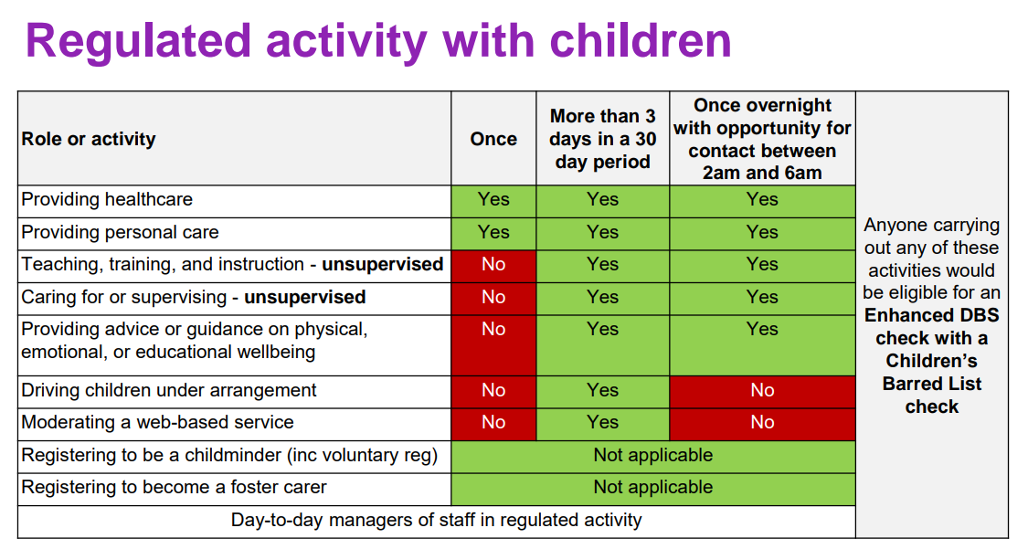
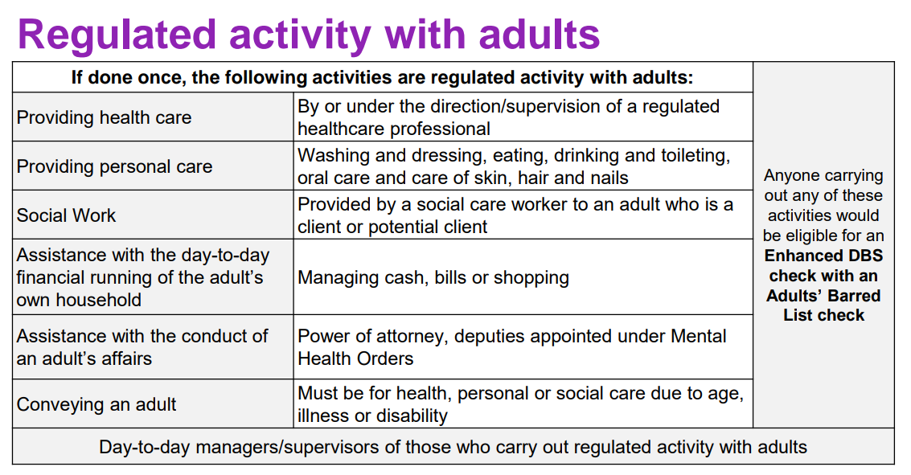

From 1st September 2026, the UK government is removing the supervision exemption for volunteers working with children. This means volunteers who teach, train, care for or supervise children will be classed as engaging in regulated activity and will require an enhanced DBS check with children’s barred List Information regardless of whether they are supervised.

SCVYS are a registered body for DBS and can process applications for member volunteers free of charge. Paid workers can also be DBS checked and we charge an admin fee for each application.

DBS have created an eligibility tool to ascertain the level of check that a role is eligible for https://www.gov.uk/find-out-dbs-check. This tool does not cover all roles so please call the SCVYS office on 01785 240378 or e mail office@staffscvys.org.uk if you require any support with the DBS process.

Applicants may join the DBS Update Service, enabling organisations to carry out status checks rather than obtaining a new DBS certificate in certain circumstances https://www.gov.uk/dbs-update-service

Where applicants have lived or worked overseas, additional criminal record checks or certificates of good conduct may be required.

