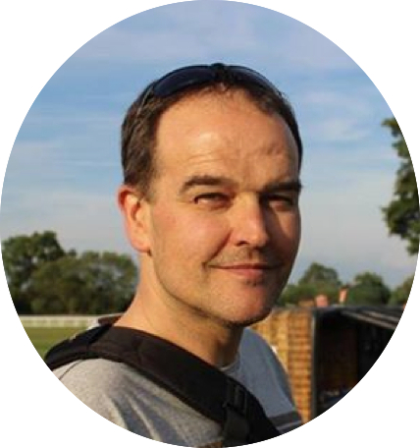
Les Simmons Youth Impact Awards Nomination Form(Over 18)

SCVYS invites member organisations to nominate individual volunteers who deserve special recognition for their voluntary service for the Les Simmons Youth Impact Award 2026. The awards, (Youth and Adult) will be presented at the SCVYS AGM in November. The awards were launched in 2016 in memory of SCVYS staff member Les Simmons, who passed away in July 2015. Les was passionate about ensuring young people achieved their full potential. Please complete the form below as fully as possible.

Name of nominee: |  |  | Age:
Organisation:
Volunteering start date (mm/yy): |  | Approximate hours per week:

- What role(s) does the nominee hold in their organisation and what are their responsibilities?

- Why did the nominee become a volunteer?

- What impact has the nominee had in their organisation and/or their local community?

- What impact has volunteering had on the nominee’s personal development?

- Any other comments about the nominee and their volunteering experience:

- Which award are you nominating this volunteer for? (optional) Please mark with a X
Youth Impact (Under 18s) |  | Adult Impact (Over 18s)

Nominated by:
Role in organisation:
Signature: | Approximate hours per week:
Date:

The deadline for nominations for the 2026 AGM will be 1st October 2026.

The Les Simmons Awards will be presented at the SCVYS AGM on Thursday 19th November.

Please contact the office on 01785 240378 for more information about this year’s AGM.

Please return completed nomination forms via email to:

office@staffscvys.org.uk

