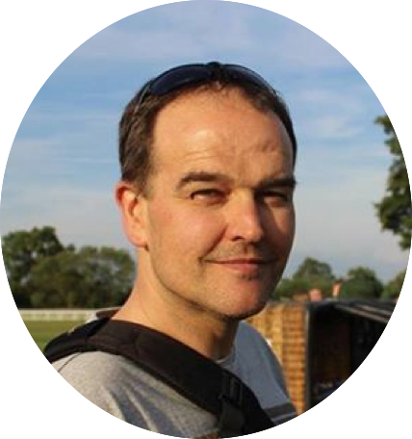
Les Simmons Youth Impact Awards Nomination Form (Organisation/Group)
SCVYS invites member organisations which have made a significant and positive impact on the lives of children and young people in Staffordshire to nominate themselves for the Les Simmons Youth Impact Award 2025. The award will be presented at the SCVYS AGM in November. The awards were launched in 2016 in memory of SCVYS staff member Les Simmons, who passed away in July 2015. Les was passionate about ensuring young people achieved their full potential. Please complete the form below as fully as possible.

Name of Organisation | Age:

- Who does the organisation aim to support? (Age range, locations, etc.)

- What does the organisation offer its members/participants?

- What impact has the organisation had on participants, volunteers and/or the local community? (Difference made, outcomes, community spirit and cohesion, etc.)

- Please add in any other comments you would like to make about the organisation and their work:

Nominated by:
Connection to organisation:
Signature: | Approximate hours per week:
Date:

The deadline for nominations for the 2025 AGM will be 1st October 2025.

The Les Simmons Awards will be presented at the SCVYS AGM on Thursday 20th November.

Please contact the office on 01785 240378 for more information about this year’s AGM.

Please return completed nomination forms via email to:

office@staffscvys.org.uk

